SMD Soldering, Easy Mode!
Smd soldering is not always the easiest thing to do. I am certainly no fan of doing smd with a solder iron, sure some of the PRO guys can solder even the tiniest components with an iron, I am certainly not one of them.
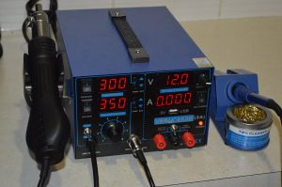
So I bought myself as fancy smd reflow solder station to do some smd boards i have with past and hot air. And let me assure you, it was money well spend as it was just so easy.
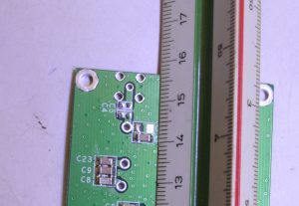
The process is very simple, add the tiniest amount of solder paste to the pads, then place the component onto the pads, the paste will hold them in place, add hot air and watch the magic happen.
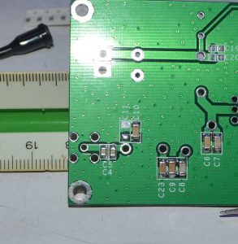
As the flux burns away, the solder coalesces and wicks to the pads and the component tabs, surface tension then pulls the components into alignment and down onto the boards pads. 9 times out of 10, leaving a perfectly solders part. See C4 and 5 in the above images.
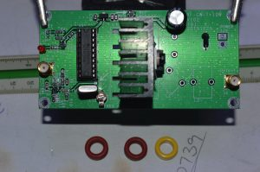
All those other things you are scared of like tiny smd transistors become cake and nothing to be feared any more. I certainly won’t be bothered with kits and projects that contain smd anymore, even ones with multi pin devices should be super easy now with hot air and solder paste.
The above is a 10w CW transmitter kit from ebay. The schematic can be found here on my blog: http://vk4ffab.info/2016/04/11/10w-radio-shortware-cw-telegraph-transmitter-7-023mhz-kits-hf-power-amplifier/
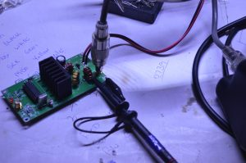
So we got it built, connected it up to an swr power meter and dummy load, as well as hooking the scope up to the output also and keying it up for the first time we get a nice 23.25 V RMS output, or 10w, I did not expect that it would deliver to the specifications, but it does, and that is kind of amazing for a cheap Chinese kit off ebay. This is in xtal mode, I still need to try it in VFO mode and see how much drive is needed to get the 10w out. But for now, I am pretty happy with how this thing works.
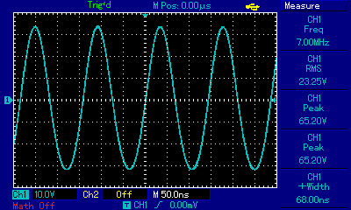

Two modes:
1, 7.023MHz CW telegraph transmitter, you can fine-tune the frequency.
2, 5-9MHz 10W power amplifier

Telegraph transmitter mode:
use the 7.023MHz frequency, transmitting power is 10W, @13.8V 1.22A
Emission control close control port, the oscillating unit has been working to avoid chirping sound.

PA mode:
input 1mW, output 10W, 40dB gain
Operating frequency range: 4-9MHz

Product Features:

Operating voltage 12-15V

Operating Current: 1.22A@13.8V

Input Output Impedance: 50 Ohm

Size: 50 * 100mm

